The Reflective Teacher: values and approaches to teaching in instrumental music education and Sistema-inspired programmes in England and around the world

Abstract
Introduction:
Over the past few years there has been an increase in interest in Sistema-inspired programmes and the adoption of formal and informal approaches to teaching music. Central to the Sistema approach is musical literacy and teaching through the ensemble, peer to peer learning, and seeking excellence in musical, social and cultural outcomes including creating a lifelong interest in music.
Aim of the Study:
This research set out to explore how the practice, values and ethos of a Sistema inspired approach impact on the ways teachers engage with children and young people in England and internationally. A further study compares and contrasts this with music instrumental teaching programmes in England.
Methodology:
Teachers engaged in Sistema-inspired programmes in Europe and Canada completed a questionnaire regarding the influences on and changes to their pedagogical practices since starting to work in their Sistema-inspired programmes. From the analysis of this research a rating scale questionnaire with 48 statements relating to pedagogic approaches, values and desired outcomes for students was created. The questionnaire was completed by 149 teachers in Sistema-inspired programmes in Canada, Colombia and Europe, (Austria, England, Romania, Slovakia, Srebrenica, Bosnia and Herzegovina, Switzerland and Wales), and by 27 music instrumental teaching programmes in England.
Results and Findings:
Analysis of Variance was undertaken. Many statements were rated highly by all teachers with a great deal of agreement and strong agreement. However, of particular interest was the range of ratings within some programmes where, within the same programme, extremes of views were held by different teachers. Statistically significant differences were found between teachers in English Sistema-inspired programmes and English music instrumental programmes (MIP) in 16 statements and, in 22 statements between Sistema-inspired programmes in different parts of the world.
Contribution to the field:
The implications for music education and Sistema-inspired programmes are discussed along with implications for further research. The results and findings raise issues relating to the importance of the teachers’ own experiences and aspirations for their students in determining the outcomes for their students; and for a coherent approach amongst all those involved in the musical education of young people, particularly those who live in challenging circumstances.

Key Words:
Music education, reflective teaching, Sistema, instrumental

Introduction
The phenomenon that is El Sistema began in Venezuela in 1975. The programme evolved over the next 30 years and, particularly over the last decade, has attracted extraordinary interest around the world.

Initially El Sistema was viewed largely positively (e.g. Govias 2011; Tunstall 2012). The 2013 literature review commissioned by Sistema Global (Creech et al 2013) revealed key areas, methods, and potential new directions for El Sistema research. Since then, interest from researchers and practitioners has grown as programmes have sought to measure their success; provide evidence to support funding applications; and to examine what changes, if any, need to be made in the pedagogy and delivery of their programmes.) The first critical book appeared in 2014 (Baker 2014). Much debate in the media followed.

Although reflective practitioner work can be traced back to the work of Dewey (Dewey 1933) since 1975 this work has also evolved (Kolb (1975; Schön 1983). Others have pointed out the importance of understanding teachers’ approaches and how their values, experiences and expectations influence their work (Booth 2012; Creech 2008; Hallam and Creech 2013; Jaramillo 2008; Mota and Figueiredo 2012; Sloboda and Davidson 1996; Ward 2004).

In the first phase of this research, following a visit to El Sistema in Venezuela by representatives of six Sistema-inspired programmes in England, a small research project explored how those teachers subsequently changed their values and approaches to teaching. A set of statements were identified as being important to those questioned, which were further explored in interviews with the programme leaders. Interest from Canada resulted in a replication of the phase 1 research in Canada. The results indicated that teacher motivation is fuelled primarily by a desire to help students achieve as well as the desire to have a social impact upon their lives. Like their English counterparts, Canadian teachers believed that success for the individual child, on a musical, personal and social level, were the key indicators of overall programme success. Over 50% of the participants reported that they had received no teacher training. Results indicated that the primary influence upon pedagogical practices was other teachers. Nonetheless participants were found to be innovative, constantly evaluating their performance, and reflective. (Lorenzino 2014).

Canadian motivational factors were consistent with English responses (achievement, social impact, inspiration, personal benefit and building relationships) and were listed in the same ranked order. Canadian and English respondents ranked learning how to teach as the most important element of effective teaching. Although Canadian respondents placed little importance on curriculum content, key objectives of Canadian and English respondents were similar, ranking behaviour development; and personal, social, and musical growth as most important. All respondents ranked other teachers, positive musical experiences and children as important influences on teaching. Canadian teachers were more apt to state that the main difference in their teaching was a “student centred” focus in a “fun” group setting. Unlike their English counterparts, several Canadian subjects noted no changes between how they were taught and how they were currently teaching.

A second research project explored how the teachers on Sistema-inspired programmes compared with teachers in English instrumental teaching programmes that had been running for over 60 years.

The aim of the current research was to explore whether teachers, or teaching artists (Booth 2009), reflected on their work and whether there were differences between the values, approaches and expectations of teachers in Sistema-programmes in Colombia, Canada and Europe.

Methodology
Qualitative research was carried out with Canadian and English subjects, which formed the basis of the research. Two overarching questions formed the basis for the study: a) What impact does involvement in el Sistema have upon teaching practices? and b) Does instructing such a programme affect one’s philosophy of teaching and pedagogy? Follow up interviews with programme leaders explored these issues in greater depth.

From the analysis of this research, a 5 point Likert rating scale questionnaire was developed. In response to statements concerning their teaching and about their pupils, teachers were asked to agree strongly; agree, disagree; disagree strongly; or choose ‘don’t know’. A scale of 1 to 10, where one equalled unimportant and 10 equalled essential, was used for statements about teachers’ values and social and musical pedagogy. The 48 statements are set out in the findings section. Questionnaires were completed by 149 teachers in Sistema-inspired programmes in Canada (n=57), (15 programmes); Colombia (n=47), (6 programmes); and Europe (n=45), (Austria, Bosnia and Herzegovina, England, Romania, Slovakia, Srebrenica, Switzerland and Wales), (13 programmes). Data were collected via Survey Monkey and analysed using Statistical Package for the Social Sciences (SPSS). A series of analyses of variance were undertaken.

Findings
In the current research Canadian, Colombian and European teachers responded to 48 statements. The responses to 22 statements were found to have statistically significant differences. There were also interesting findings where differences were not statistically significant.

In respect of their values, teachers rated the importance of two statements: ‘my pupils’ social well-being is important to me’; and ‘my pupils’ musical achievement is important to me’. There were no statistically significant differences in the responses to the statement ‘my pupils’ social well-being is important to me’. The overall mean was 9.71 (10 = essential). The mean for the Canadian Sistemas was 9.58; for European Sistemas 9.64; and for the Colombian programmes 9.94. However there were significant differences between the Colombian responses and those for Europe (p=.017) and Canada (p=.000) in response to the statement ‘my pupils’ musical achievement is important to me’. The overall mean was 9.02 with Canada’s mean 8.42; Europe’s 8.97; and the Colombians 9.78. All but 3 Colombians (94%) scored 10 ‘essential’ compared with 53% of the Europeans and 40% of the Canadians. See Table 1.

Table 1. Range of scores for ‘my values’: my pupils’ musical achievement is important to me.
Scale (1 = not important at all; 10 = essential) | 1 | 2 | 3 | 4 | 5 | 6 | 7 | 8 | 9 | 10
Europe (N=45) |  |  |  |  |  | 2 | 5 | 9 | 5 | 24
Canada (N=57) |  | 1 |  | 1 |  | 3 | 12 | 11 | 6 | 23
Colombia (N=47) |  |  |  | 1 |  |  | 1 |  | 1 | 44

Teachers were also asked about their teaching on a Likert scale of 1 to 5, where 1 equals agree strongly; 4 equals disagree strongly and 5 equals ‘don’t know’. Those who responded ‘don’t know’ are not included. See Figure 1.

Figure 1: Overall mean scores for aspects of teaching
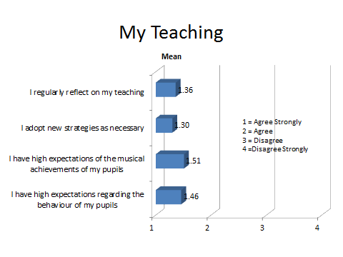
There were no statistically significant differences regarding regularly reflecting on teaching; adopting new strategies as necessary; or teachers’ expectations of their pupils’ behaviour, but there was a significant difference between the Colombian and Canadian responses (p=.030) to the statement ‘I have high musical expectations of my pupils’. Only one Colombian respondent disagreed, 25 (54%) agreed strongly and 20 (43%) agreed (n=46). In contrast, 3 European respondents disagreed, 28 (62%) agreed strongly and 14 (31%) agreed (n = 45); whilst one Canadian respondent disagreed strongly, 3 disagreed, 22 (41%) agreed strongly and 28 (52%) agreed (n = 54). See Table 2.

Table 2. Range of scores for ‘my teaching’: I have high musical expectations of my pupils.
4 = Disagree Strongly; 1 = Agree Strongly | 4 | 3 | 2 | 1
Colombia |  | 1 | 20 | 25
Canada |  | 3 | 14 | 28
Europe | 1 | 3 | 28 | 22

Overall means for nine social and musical pedagogy statements relating to music are presented in Figure 2.

Figure 2: Overall means for the importance of musical and social pedagogical statements (musical)
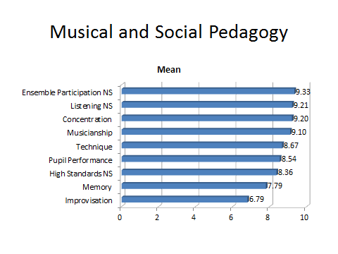
There were no statistically significant differences between the respondents in respect of the importance they attached to ensemble participation, listening, or high standards. Statistically significant differences were found with the Colombian respondents consistently rating factors more highly than their Canadian and European counterparts in respect of concentration (Canada p=.009 and Europe p=.009); musicianship (Canada p=.001); technique (Canada p=.000 and Europe p=.003); pupil performance (Canada p=.000 and Europe p=.009); memory (Canada p=.000 and Europe p=.001); and improvisation (Canada p=.005).

Several teachers scored 10 (essential) for all statements in all programmes. However, the ranges of scores are of interest. For concentration and for musicianship the lowest score for Colombian respondents was 7; for Europe 6; and for Canada 5. For technique the lowest score for the Colombian respondents was also 7, but for Europe it was 3 and for Canada 1. Both the Colombians and Canadians ranged from 5 to 10 for the importance of pupil performance with the lowest European score being 4. All aspects of pedagogy except memory (mean = 7.79), and improvisation (mean = 6.79) had means of more than 8. For memory the Colombian and European responses ranged from 4 to 10 whilst the Canadians had the full range from 1 to 10. The importance of improvisation had Colombians, Canadians and Europeans covering the full range from 1 (not important at all) to 10 (essential).

Teachers were also asked to rate the importance of a love of music, of their instrument, and of establishing a lifelong interest in music. See Figure 3.

Figure 3: Overall means for the importance of love of music, love of their instrument and establishing a lifelong interest in music
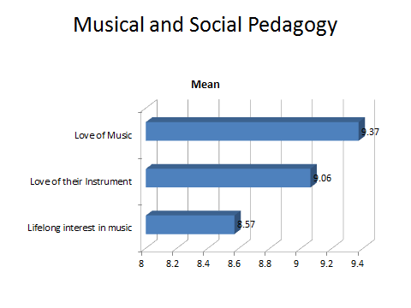
Statistically significant differences were found between the programmes with the Colombian respondents consistently rating these aspects as being very important. For ‘the importance of the love of music’ the Colombian mean was 9.82 whilst Canada’s mean was 9.37 (NS) and Europe’s mean 8.91 (p=.000). Differences were statistically significant for both love of instrument (Canada p=.003 and Europe p=.001) and for establishing a lifelong interest in music (Canada and Europe both p=.001).

There were also statistically significant differences in the following six statements relating to approaches to teaching: the importance of active, holistic learning; incorporating visual and aural aspects of learning; linking singing and playing; providing appropriately differentiated materials; promoting independent learning and of using solfa/solfège. The overall means are shown in Figure 4 with all, except using solfa/solfège, having a mean greater than 8. For the importance of active holistic learning, the range for Colombia and Europe was 4 to 10, whilst the lowest rating for Canada was 5. Despite this, only Colombia and Canada were statistically significantly different (p=.027), with means of 9.36 (Colombia), 8.77 (Europe), and 8.67 (Canada). Similarly for the importance of incorporating visual and aural aspects of learning, the lower ratings were 5 Canada, (mean = 8.51), 6 Europe, (mean = 8.98), and 7 Colombia, (mean = 9.24) with statistically significant differences between Colombia and Canada (p=.009). The range for the importance of linking singing and playing was from 6 to 10 for the Colombian respondents (mean = 9.42), 2 to 10 for the Canadians (mean = 8.23) and 1 to 10 for the Europeans (mean = 9.13) resulting in statistically significant differences between Colombia and Canada (p=.001) and between Europe and Canada (p=.012). The Colombian respondents (mean = 9.39; range 8 to 10) also rated providing appropriately differentiated materials statistically significantly higher than Canada (mean = 8.18; range 3 to 10; sig p=.000). European responses were also statistically significantly different to Canada for providing appropriately differentiated materials (mean = 9.04; range 6 to 10; sig p=.005). The importance of independent learning was similarly rated more highly by Colombia (mean = 9.52; range 7 to 10) than both Canada (mean = 8.25; range 4 to 10; sig p=.000); and Europe (mean 8.60; range 3 to 10; sig p=.005). The importance of Solfa/Solfége (overall mean = 5.89) produced a wider ranges of ratings: Colombia (mean = 8.15; range 2 to 10); Europe (Mean = 6.27; range 1 to 10; sig p=.003); Canada (mean = 3.78; range 2 to 10; sig p=.000). European responses were also statistically significantly different from the Canadian ones (p=.000).

Figure 4: Overall means for six pedagogical approaches to musical and social pedagogy
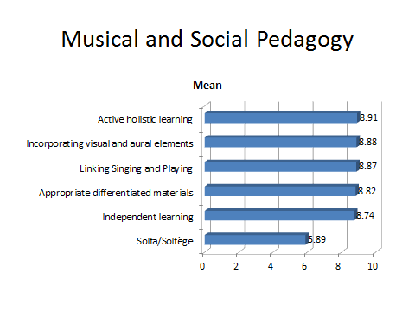
The next group of statements relate to social aspects of pedagogy. See Figure 5. Only the importance of providing a stress free activity was statistically significantly different. Colombian respondents had a mean of 9.11 with a range of ratings from 3 to 10; Canadians had the same range, but with a mean of 7.82 (sig p=.002); and the European ratings ranged from 1 to 10 with a mean of 8.02 (sig p=.016).

Figure 5: Overall means for musical and social pedagogical statements (Social)
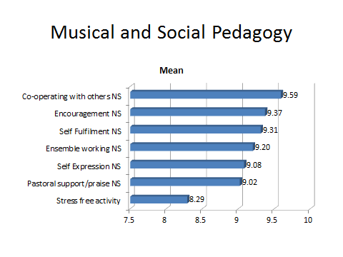
The final group of statements under musical and social pedagogy related to personal attributes. See Figure 6. All had overall means above 9. There were no statistically significantly different findings for the importance of confidence or achieving potential, but there were statistically significant differences for both the importance of enthusiasm and discipline. For enthusiasm the range for both Colombia (mean = 9.67) and Canada (mean = 9.37) was 7 to 10, whilst European ratings ranged from 5 to 10 (mean = 9.0; p=.004 with Colombia). For discipline the Colombian rating range was 8 to 10 (mean = 9.8) compared with the Canadians (range 5 to 10; mean = 9.05; p=.002) and the Europeans (range 5 to 10; mean = 8.53; p=.000).

Figure 6: Overall means for musical and social pedagogical aspects (personal)
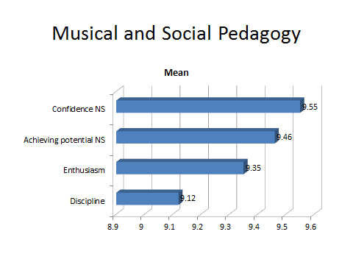
Statements relating to teachers’ perceptions of their pupils were presented with which the teachers agreed strongly (1), agreed (2), disagreed (3), or disagreed strongly (4). Those who responded ‘don’t know’ are excluded. (See Figure 7).

Figure 7: Overall means for statements regarding ‘my pupils’
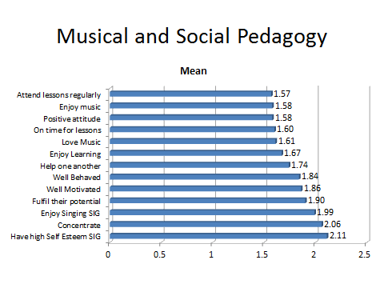
Only two of these statements were statistically significantly different: my pupils generally have high levels of self-esteem; and my pupils enjoy singing. Whilst the Colombian responses to levels of self-esteem (mean = 1.87) included ‘disagree’; both the Canadian (mean = 2.25; p=.019) and European (mean = 2.16) responses also included ‘disagree strongly’. My pupils enjoy singing was the only statement for which the Colombians (mean = 2.33) had a lower rating than the Canadian (mean = 1.81) and European respondents (mean = 1.81) and for which there was a statistical difference with Canadians (p=.000) and Europeans (p=.001).

Discussion and conclusions
The aim of the research was to explore whether there were differences in the experiences, approaches, values and expectations of teachers. The literature on teaching artists and reflective practice suggests that what we teach is who we are. (Booth 2012). Each person is a product of their experiences to date. Changes that the individual makes are as a result of their reflections on those experiences. Furthermore, those reflections are informed by the teachers’ beliefs and values and by the purpose of the music programme. (Booth 2009; Creech 2008; Hallam and Creech 2013; Jaramillo 2008; Mota and Figueiredo 2012; Sloboda and Davidson 1996; Ward 2004). Together, these are major factors in how she or he teaches and what their students learn. The experiences and expectations of the teachers are a major consideration in determining the success or otherwise of their students and how success is perceived.

Teachers agreed or agreed strongly with the statements that they regularly reflect on their teaching and adopt new strategies as necessary. However reflecting on their teaching is no guarantee that their teaching will be better. A teacher with low expectations may reflect that all is well and decide that new strategies are not necessary. It is the teachers’ view of the potential of a pupil that will determine whether the teacher believes the pupil is achieving their potential. New strategies will only be employed where the existing strategies are perceived by the teacher to be unsuccessful.

There were no significant differences regarding whether teachers felt their pupils behaved well or were well motivated; whether they enjoyed music or enjoyed learning. But these judgements are determined by teachers’ expectations of behaviour and their perception of whether the pupils were motivated or should enjoy music and learning.

Nevertheless, the overwhelming number of teachers/teaching artists in the Sistema-inspired programmes in Canada, Colombia and Europe rate both musical excellence and social development very highly. On statements scoring 1, as not important at all through to 10, essential, only Solfa/Solfège (mean 5.89); improvisation (mean 6.79); and memory (mean 7.79) had overall means of less than 8. However, the Colombian responses were statistically significantly higher than Canadian and/or European responses on 19 of the 31 statements that used this 10 point scale. The importance of the Colombian’s pupils’ musical achievement to the teacher was statistically significantly higher and it is therefore perhaps not surprising that this difference continued into many of the musical aspects of their teaching including concentration, musicianship, technique, performance, improvisation and memory; as well as love of music, love of their instrument and encouraging a lifelong interest in music. Furthermore, this also applied to their approaches to teaching including holistic learning, incorporating visual and aural aspects of learning and linking singing and playing as well as providing appropriately differentiated materials. In contrast, with regard to those social aspects of pedagogy, only providing a stress-free activity was significantly different statistically. These differences may be a result of cultural contextual approaches but nonetheless provide cause for reflection.

Whilst many music teachers work in isolation, teachers in Sistema-inspired programmes tend to work more as a team. Since consistency of approach is important to children, particularly those who come from disadvantaged backgrounds, agreement about values, approaches and expectations between teachers on these programmes is important. As, in many cases, there are relatively few teachers in any one programme each individual’s views are potentially more important than the statistical analysis might indicate. It is therefore important to note the range of ratings, particularly those relating to pedagogical approaches.

The statistically significant differences do not necessarily indicate one approach is better than another and no value judgements are implied by the findings. These are matters for the programmes to consider. For example, responses to the statement that ‘my pupils generally have high levels of self-esteem’ may be the result of a number of factors, including how long the programme had been running. A teacher may have agreed with the statement because their students started with low self-esteem and, following extensive engagement with their programme, self-esteem improved. Equally, disagreeing with the statement and recognising that students have low self-esteem does not mean that the teacher is not influenced by this and may reflect on their practices, adopting strategies as necessary to improve the self-esteem of their pupils.

Sistema-inspired programmes do not generally set out to replace music education programmes. However, one outcome of the methodology is that there were no questions around creativity, composing or issues of musical knowledge relating to context, style or history, which form an integral part of many music education programmes. Indeed, the importance of improvisation, which is associated with composing and essential to the jazz genre, scored one of the lowest means with Canadian, Colombian and European teachers scoring the full range from 1 to 10. The views of pupils/students would provide a valuable insight into these programmes, but these were not sought because the focus of this research was specifically on the teachers’ own views, approaches and values.

The results and findings raise issues relating to the importance of the teachers’ own experiences and aspirations for their students in determining the outcomes for their students; and for a coherent approach amongst all those working with young people, particularly those who live in challenging circumstances.

References
Baker, G. (2014) El Sistema: Orchestrating Venezuela’s Youth. New York. Oxford University Press.

Booth, E. (2009) The Music Teaching Artist’s Bible. New York. Oxford University Press.

Booth, E. (2012). The Law of 80% What You Teach is What you Are. Carnegie Hall https://www.youtube.com/watch?v=L15Jvs-G4Xw accessed 9 September 2014

Creech, A. (2008). Interpersonal dynamics and teacher objectives in instrumental teaching. Paper submitted for the 22nd International Research Seminar, Porto, Portugal, 13 –18 July 2008.

Creech, A. Gonzalez-oreno, P. Lorenzino, L. Waitman, G. (2013) El Sistema and Sistema-Inspired Programmes: A Literature Review of research, evaluation, and critical debate. San Diego, Sistema Global

Dewey, J. (1933). How We Think. Boston, MA: D. C. Heath & Co.

Govias, J. (2011). The Five Fundamentals of El Sistema. The Canadian Music Educator, Fall, 21-23 https://elsistemausa.files.wordpress.com/2011/09/govias-five-fundamentals-of-el-sistema.pdf accessed 9 September 2014.

Hallam, R. and Creech, A. (2013) Teacher reflections on the impact of Sistema inspired programmes on their teaching. The reflective teacher EAS conference, Leuven, Belgium. 14 February 2013.

Jaramillo, J. (2008). The music educator’s professional knowledge. Music Education Research, 10(3), 347–359.DOI: 10.1080/14613800802280084. p. 349).

Kolb, D.A. and Fry, R. (1975) ‘Toward an applied theory of experiential learning’ in C Cooper (ed) Theories of Group Process, London: John Wiley

Lorenzino, L. (2014). Sistema Canada teacher reflections. Poster presentation for the National Association for Music Education (NAFME) 2014 Music Research & Teacher Education National Conference, St. Louis, Missouri.

Mota, G. and Figueiredo, S. (2012). Initiating music programs in new contexts: in search of a democratic music education. In G. McPherson and G. Welch (eds.), The Oxford Handbook of Music Education Volume 1 (pp 187 – 204). Oxford: Oxford University Press.

Schön, D. (1983) The Reflective Practitioner New York: Basic Books

Sloboda, J. and Davidson, J. (1996). The young performing musician. In I. Deliege, and J. Sloboda eds, Musical beginnings: Origins and development of musical competence. (pp171-190). Oxford, England: Oxford Press

Tunstall, T. (2012) Changing Lives. New York. WW Norton & Co., Inc.

Ward V. (2004). Good performance, music analysis and instrumental teaching: Towards an understanding of the aims and objectives of instrumental teachers. Music Education Research, 6(2), 191–215.DOI: 10.1080/1363243041000222491. (p. 213).

